UID Lab 3

**Difference between Command Line Interface, Graphical User Interface and Voice User Interface**

**CLI**

🔹 Simple and lightweight command-line script.  
🔹 Rename files using terminal commands.  
🔹 Ideal for developers and automation scripts.

**Program:**

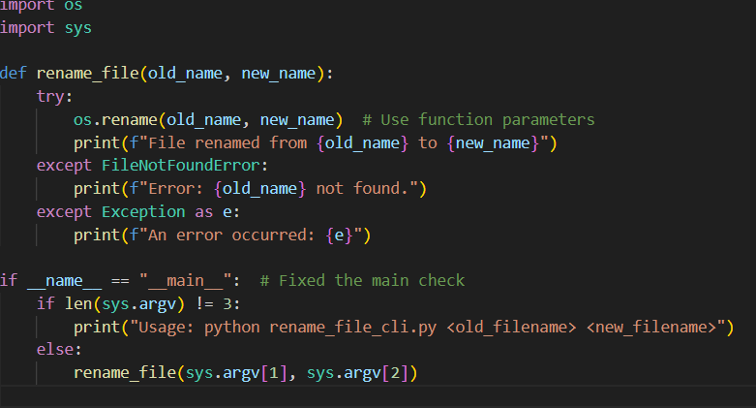  
**Command:  
  
  
Output:**  **GUI:**🔹 User-friendly interface using Tkinter.  
🔹 Allows easy input of filenames.  
🔹 Ideal for non-technical users.

**Program:  
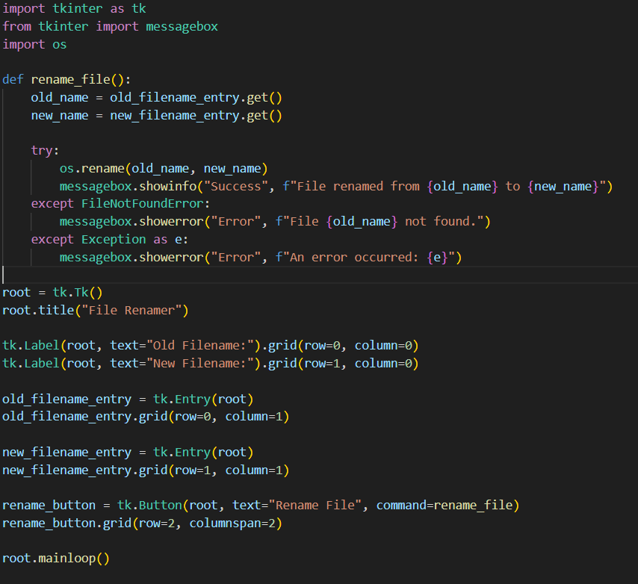**

**Command:**  


**Output:**

**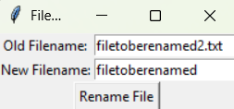  
  
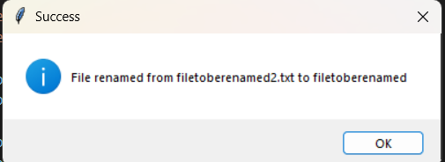  
  
  
VUI:**🔹 Uses Speech Recognition to rename files.  
🔹 Hands-free operation using voice commands.  
🔹 Suitable for accessibility and innovative automation.  
  
**Program:  
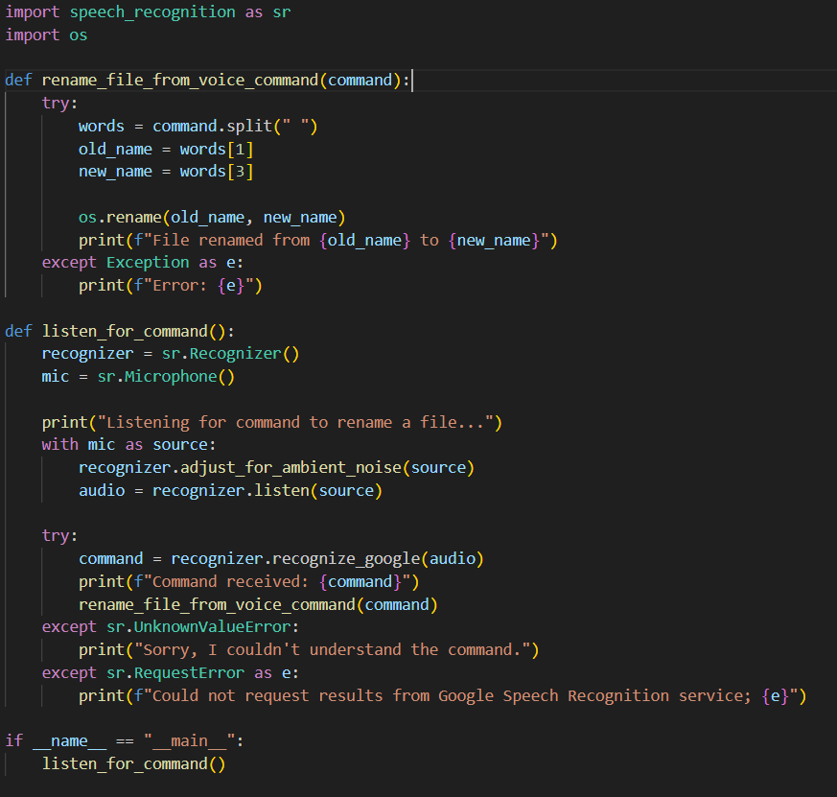  
  
Command:  
  
  
Output:  
  
**